Opening the Web Application

1. Start SQL
2. Copy the Create Tables code and run the query to create the Database tables with the SQL
3. Open the Visual Studio file “PlayersDB.sln”
4. After running see the resulting page

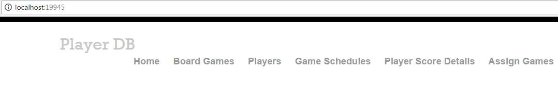

1. Create Board Games

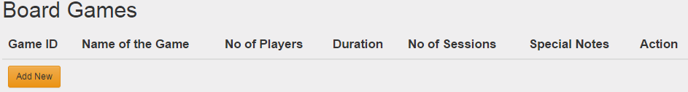

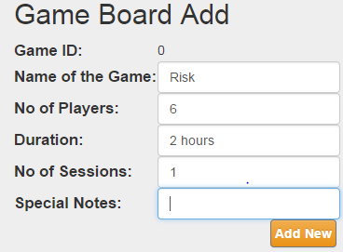

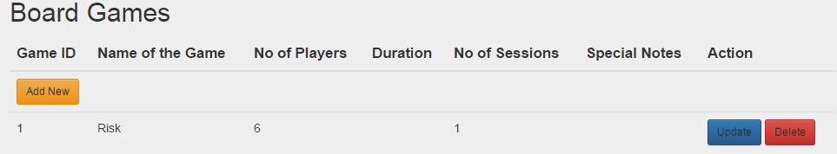

1. Create Players

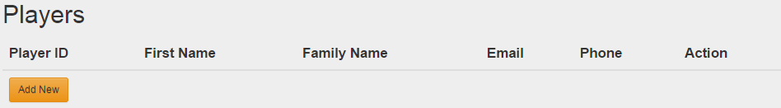

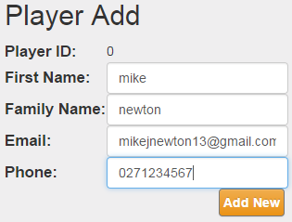

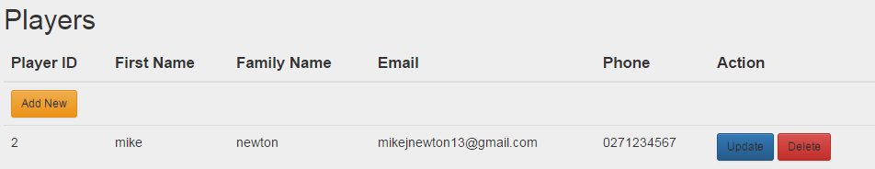

1. Game Schedules

